Domestic TANK installation Requirements

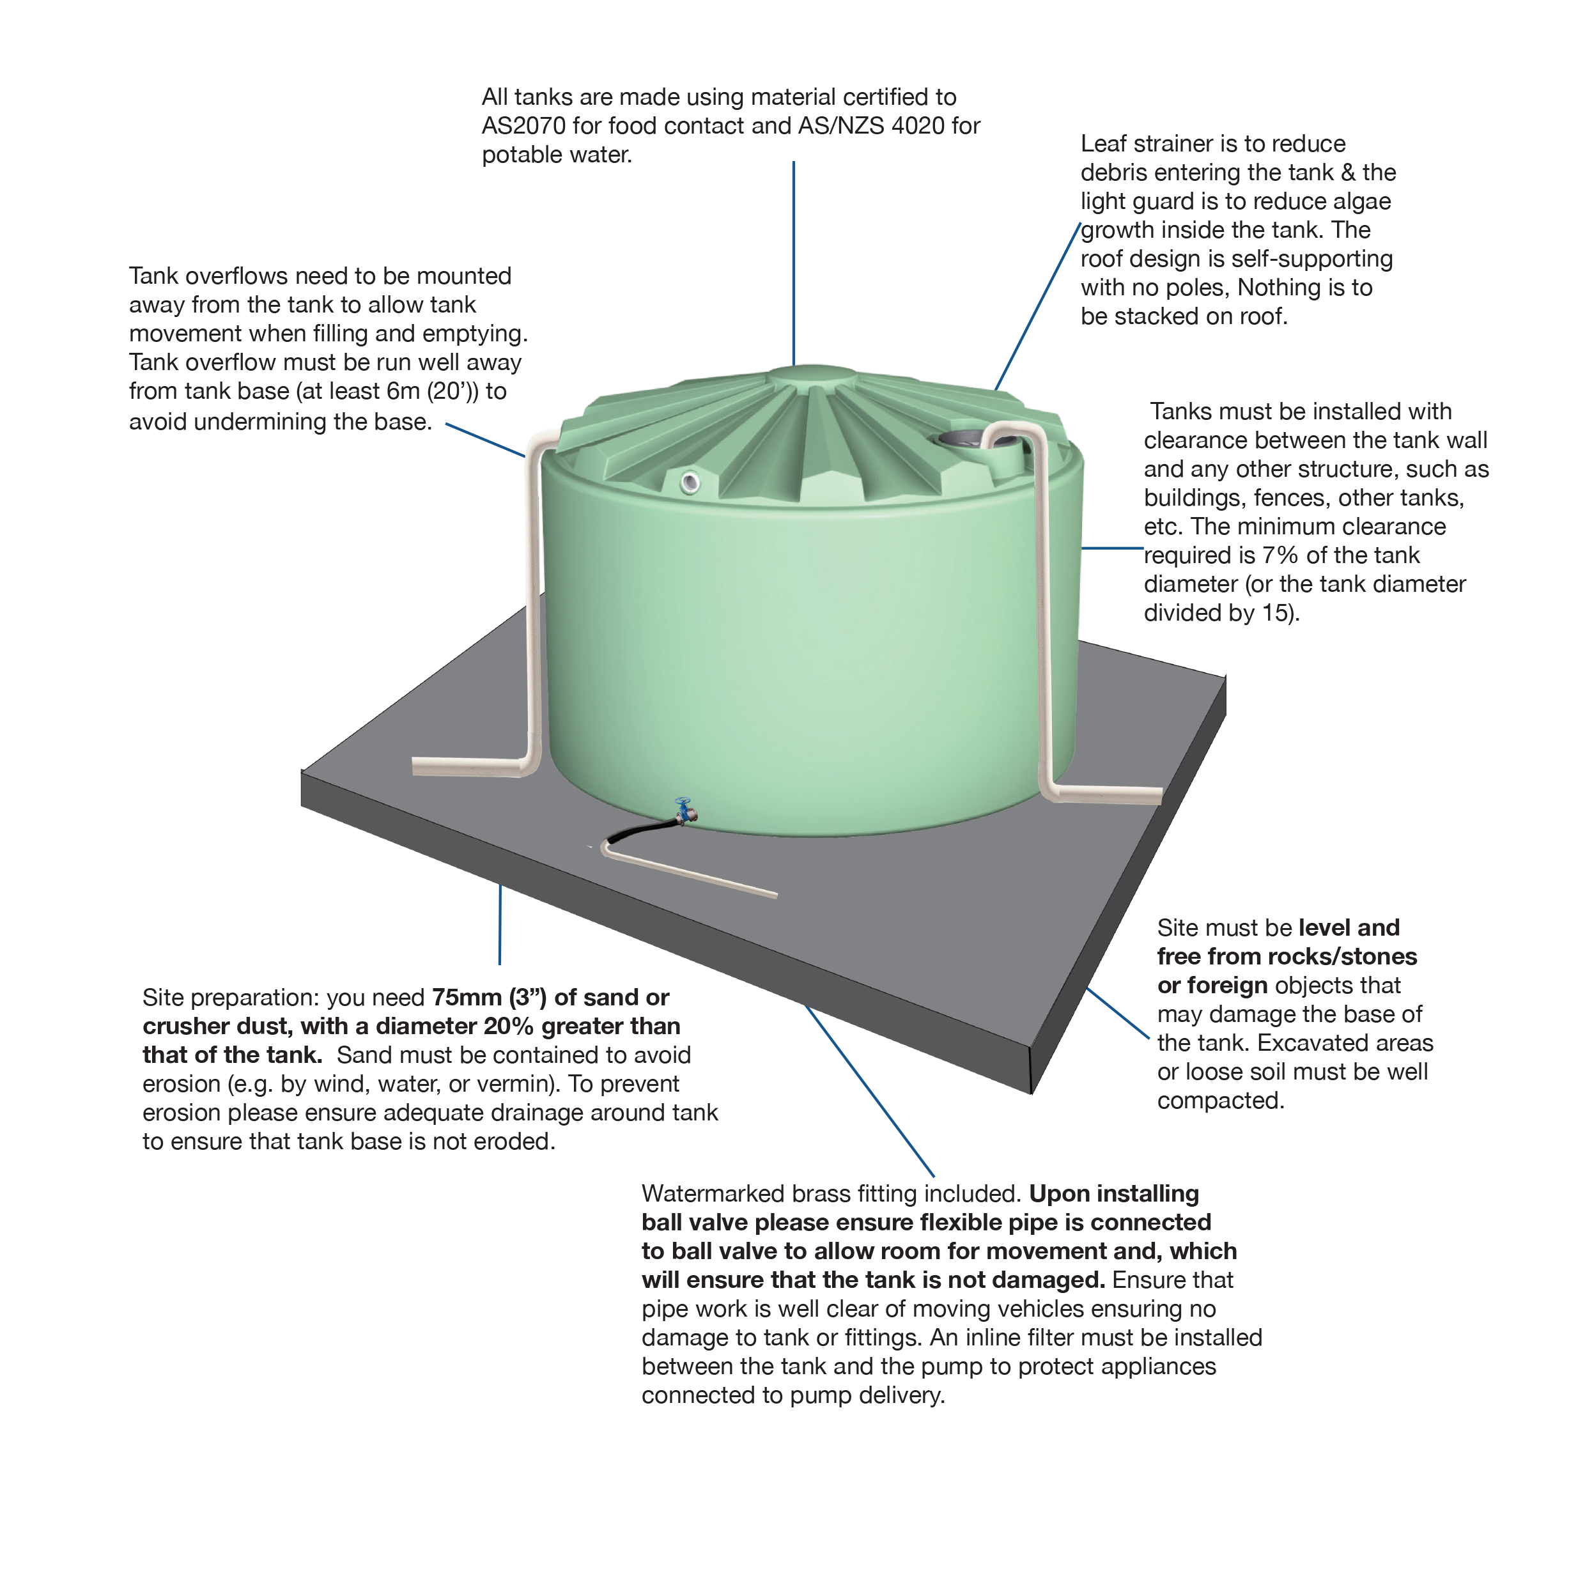
It is the purchaser’s responsibility to ensure that the tank is secured immediately following delivery, either by tying down with rope or wire, or by filling to sufficient weight to ensure it is secure.
Tank Stands: Have to be designed by a engineer
Global Rotomoulding takes no responsibility for the suitability of tank stands. Bearers must have sufficient strength to prevent deflection when the tank is full. Use hardwood decking with a maximum gap of 12mm (1/2”) between slats, or exterior grade plywood. Do not use corrugated iron. Support inlet/outlet pipes from tank stand, and not from tank wall.
• Tank must not be moved from its original installation site.
• Tank installation must comply with local council requirements.
FAILURE TO COMPLY WITH THE INSTALLATION REQUIREMENTS WILL VOID YOUR WARRANTY.

